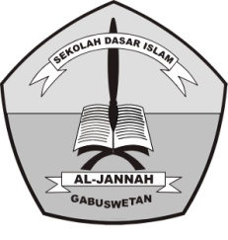**PENILAIAN TENGAH SEMESTER (PTS) GANJIL**

**TAHUN PELAJARAN 2018/2019**

SD ISLAM AL-JANNAH

**Jl. Raya Gabuswetan No. 01 tlp (0234) 5508501**

**Desa Gabuswetan Kecamatan Gabuswetan – Indramayu 45263**

**Email : sdi.aljannah@gmail.com Website :http://www.sdi-aljannah.web.id**

Nama : Hari / Tanggal : , September 2018

Kelas : I (Satu) Mata Pelajaran : Bahasa Inggris

1. **Berilah tanda silang (X) pada huruf A, B, atau C pada pilihan jawaban yang benar di lembar jawaban yang tersedia!**
2. What is two plus four? it is ……

a. six

2 + 6 = ?

b. seven

c. eight

1. The color of avocado is.....

A. red

B. green

C. blue

1. 

A. book

B. ruler

C. eraser

1. What is this? This is.....

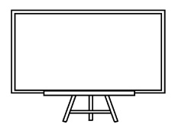A. chair

B. table

C. whiteboard

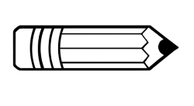

A. pen

B. shoes

C. pencil

1. 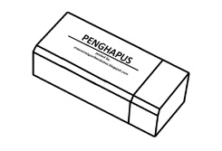What is this? This is a

A. sharpener

B. eraser

C. book

1. Rina : Good evening, Abi.

Abi : Good …

A. How are you

B. Thank you

C. Evening

1. Abu-abu in English is.....

A. green

B. yellow

C. grey

1. Rita : Good night, Ali.

Ali : .........…

A. Good morning

B. Good evening

C. Good night

A. fifteen

B. sixteen

C. seventeen

1. A : Hi, Deni. How are you?

B : ……thank you

* 1. How are you
  2. I am fine
  3. Nice to meet you

1. 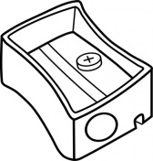What is this? This is a.....

A. eraser

B. sharpener

C. pen

1. 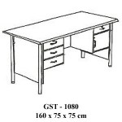What is that? That is.....

A. table

B. eraser

C. pencil

1. Rizal : Good morning, Albi.

Albi : Good …

A. How are you

B. Thank you

C. Morning

1. Chair in Indonesia is…..
2. Lemari B. meja C. Kursi
3. How many apples are there?

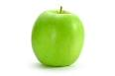

1. Six
2. Eight
3. Seven
4. Nuha : what number is it?

Adam : it is number ……

A. eleven

B. twelve

C. thirteen

1. How many marbles are there?

A. seven

B. eight

C. nine

1. The color of our hair is ***blue***. Black means…

A. kuning B. hitam C. biru

1. Yellow in Indonesia is…..
2. Kuning
3. Hijau
4. Merah
5. **Fill in the blank with the right answer!**
   1. The colors of Indonesian flag are............... and ...............



* 1. We have …… fingers.

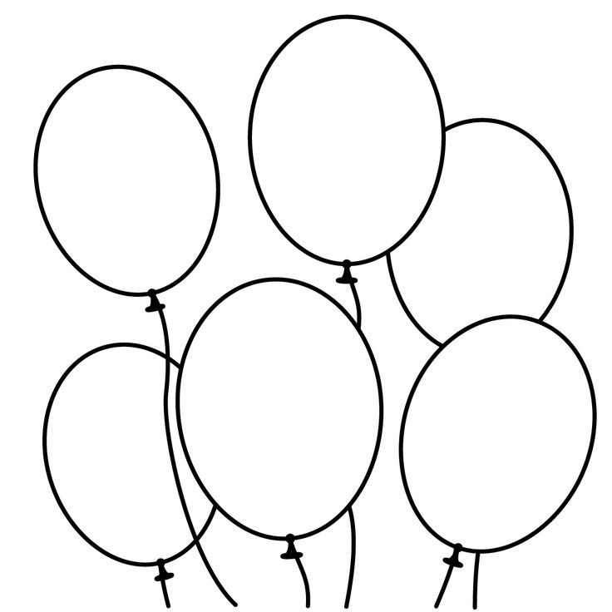

* 1. How many balloons are there…..

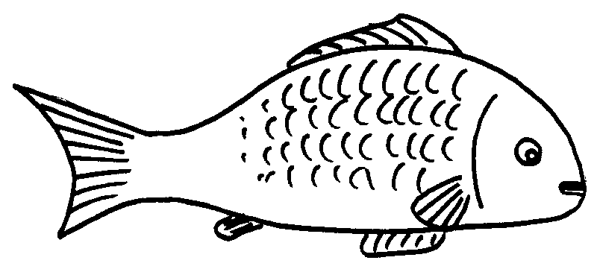

* 1. There is a…..in the pond
  2. It is number…..